**PROJECT REPORT**

ON

**“AN OPEN SOURCE MINIATURE ROBOTIC DEVELOPMENT PLATFORM”**

Submitted in partial fulfilment of the requirements for the partial completion of

**PROJECT FOR COMMUNITY SERVICE [16EC7DCPW1]**

IN

**ELECTRONICS AND COMMUNICATION ENGINEERING**

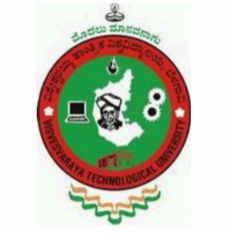

**VISVESVARAYA TECHNOLOGICAL UNIVERSITY, BELGAUM**

SUBMITTED BY

**ADITYA BHAT K 1BM14EC001**

**AKSHAY U HEGDE** **1BM14EC005**

**ASHWIN N** **1BM14EC012**

**HEETHESH VHAVLE 1BM14EC038**

Under the Guidance of

H.N. LATHA

(Assistant Professor, ECE, BMSCE)

**August - December 2017**

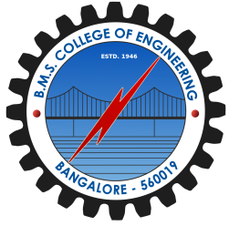

Department of Electronics and Communication Engineering

**B.M.S. COLLEGE OF ENGINEERING**

(Autonomous College Affiliated to Visvesvaraya Technological University, Belgaum)

Bull Temple Road, Basavanagudi, Bangalore-560019